**JFROG Repository 25/07/23**

**Download the Dependencies from the JFROG repository for Maven Build.**

Step 1: Create a EC2 instance to install the Jfrog.

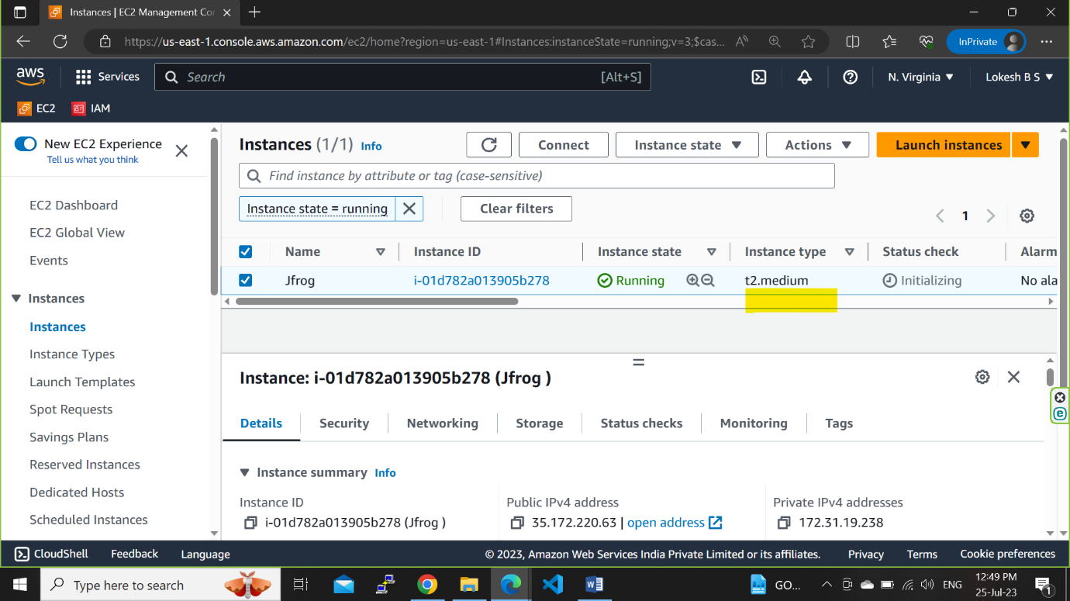

Step 2: Copy the Github URL for Jfrog Installation 🡪 <https://github.com/AnandReddy-1565/jfrog-installation.git>

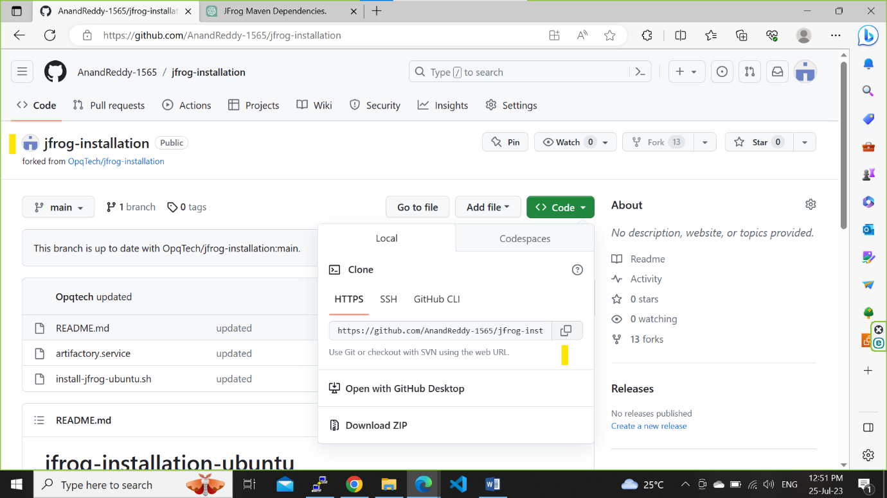

Step 3: Clone the Git URL and install the Jfrog

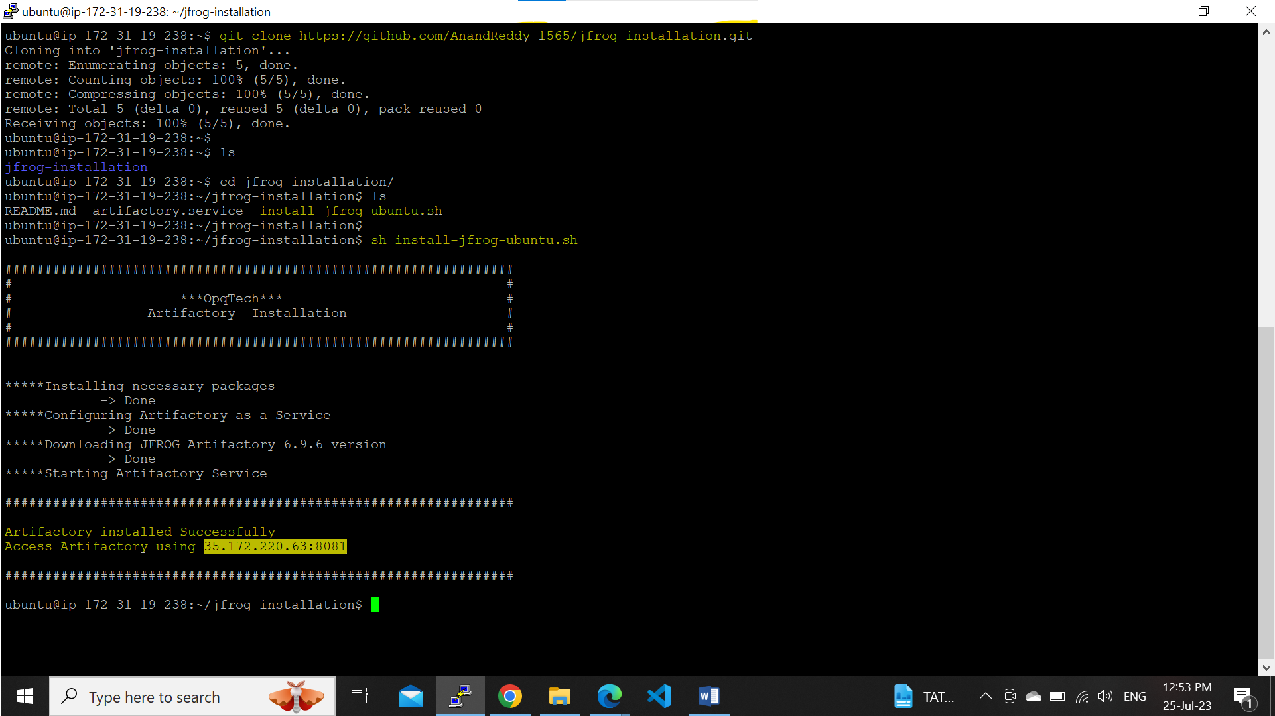

Step 4: copy the public ip address and port no. – 8081 to Login to the Jfrog webpage. 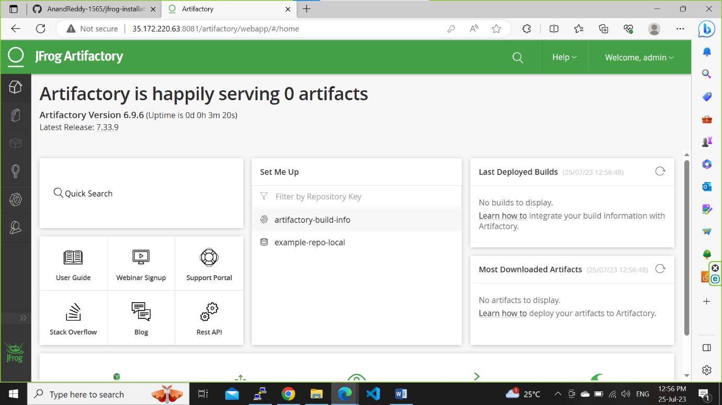

Step 5: Create Local, Remote and virtual Repositories in Jfrog UI.

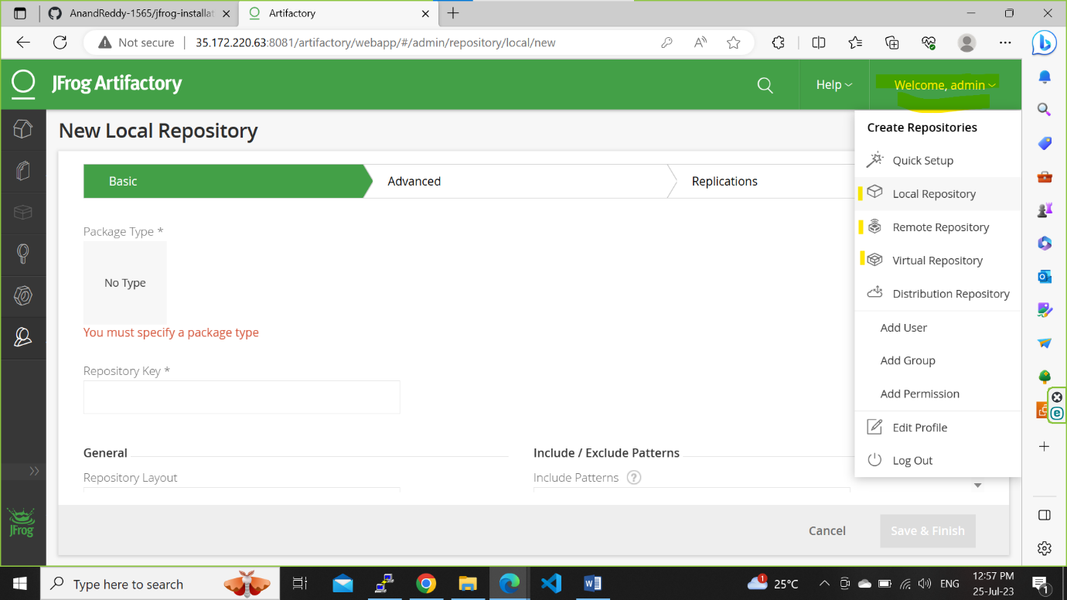

Select the maven package type

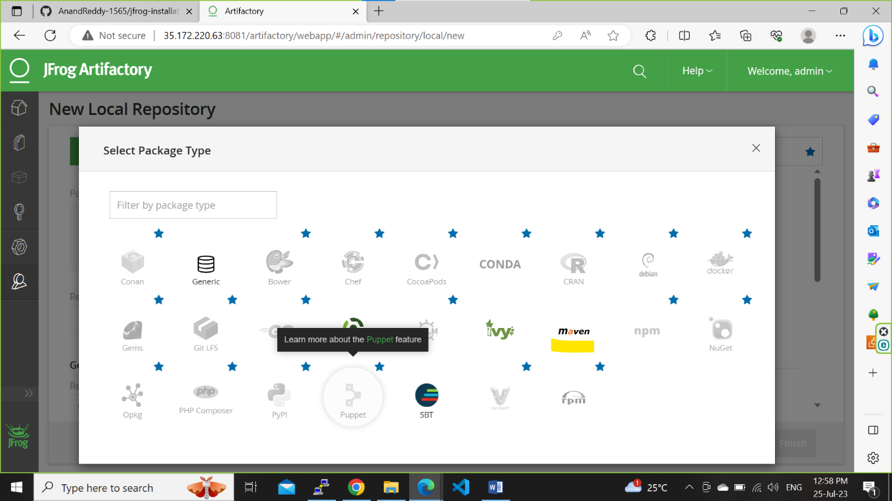

For Local-Snapshot Repository

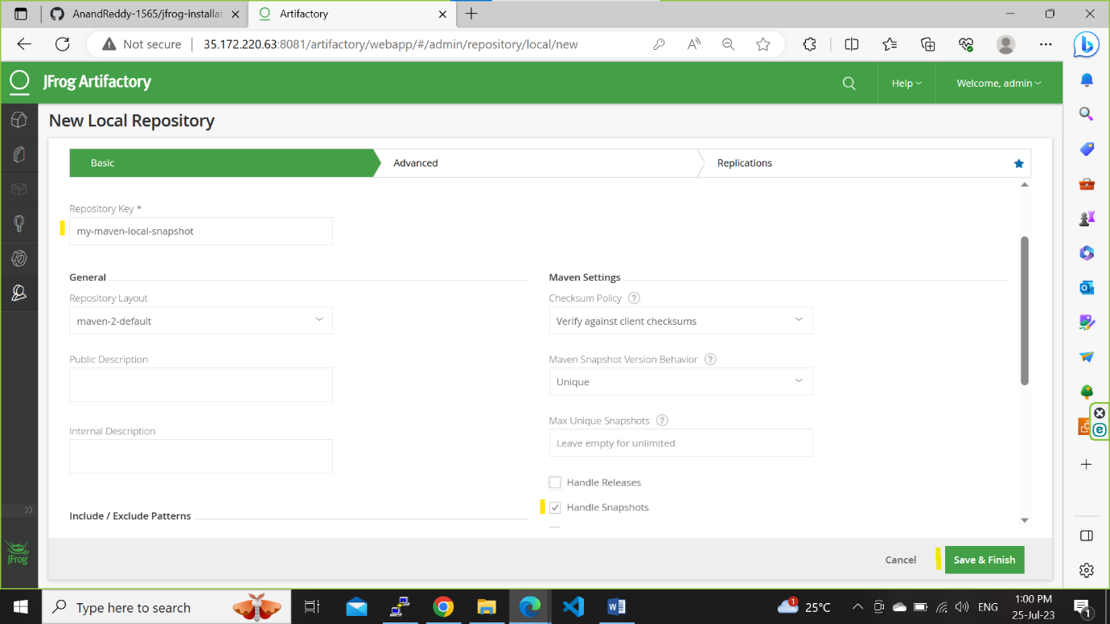

For Local-Releases Repository

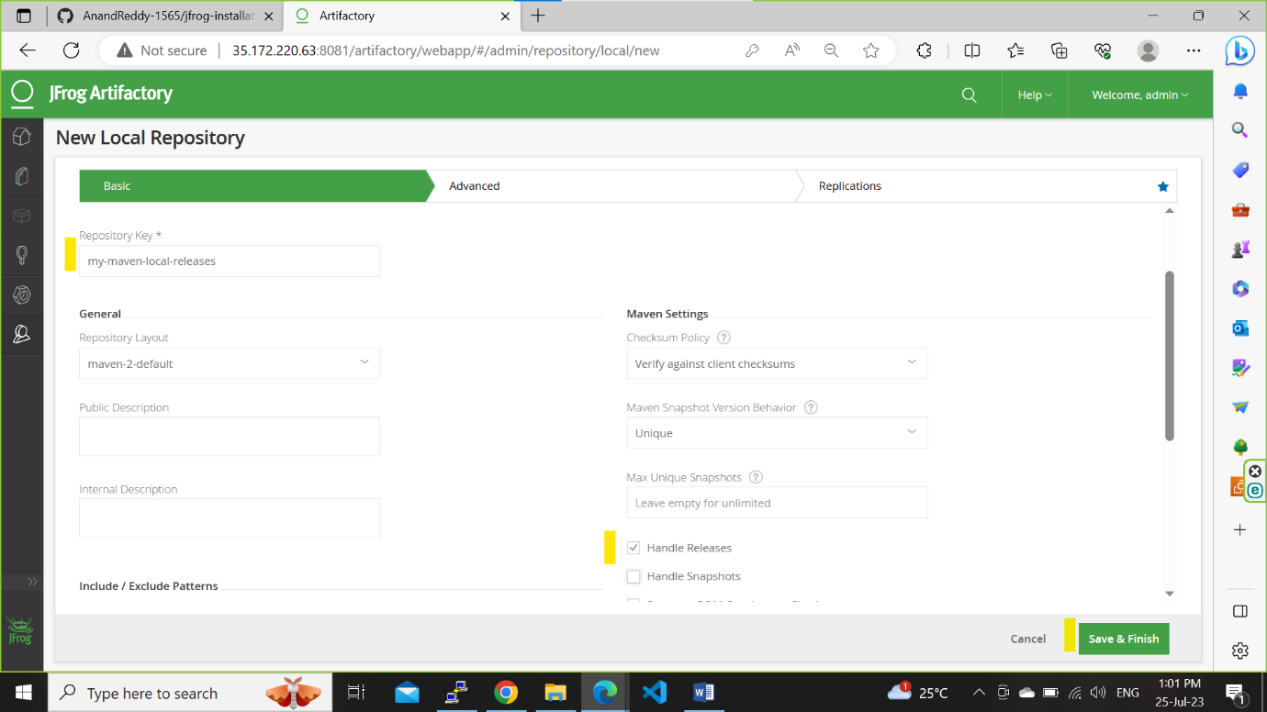

For Remote-Releases Repository

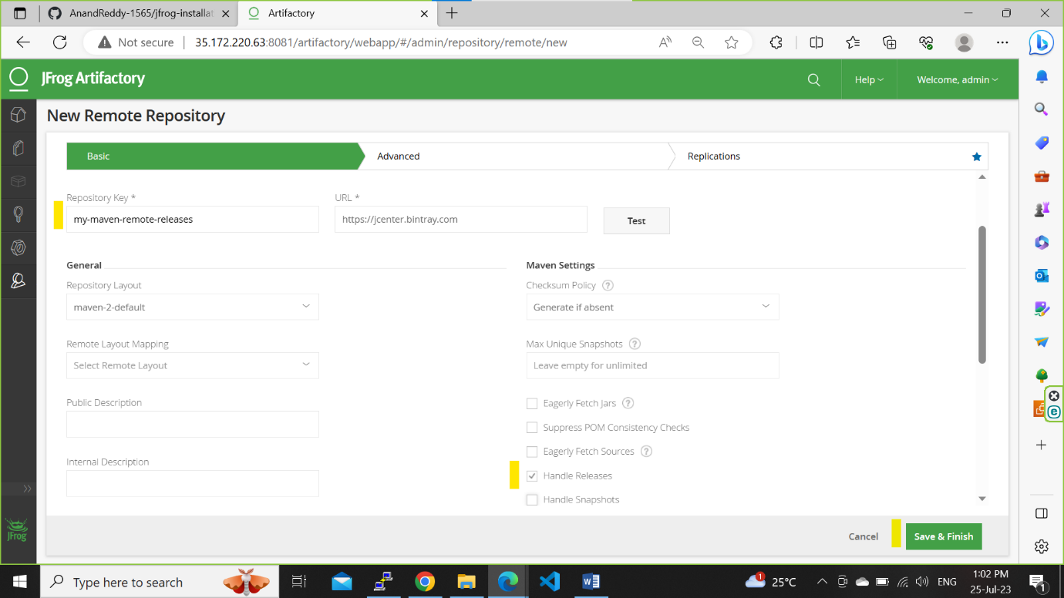

For Virtual-Snapshot Repository and select the both Local-Snapshot and Remote-Releases

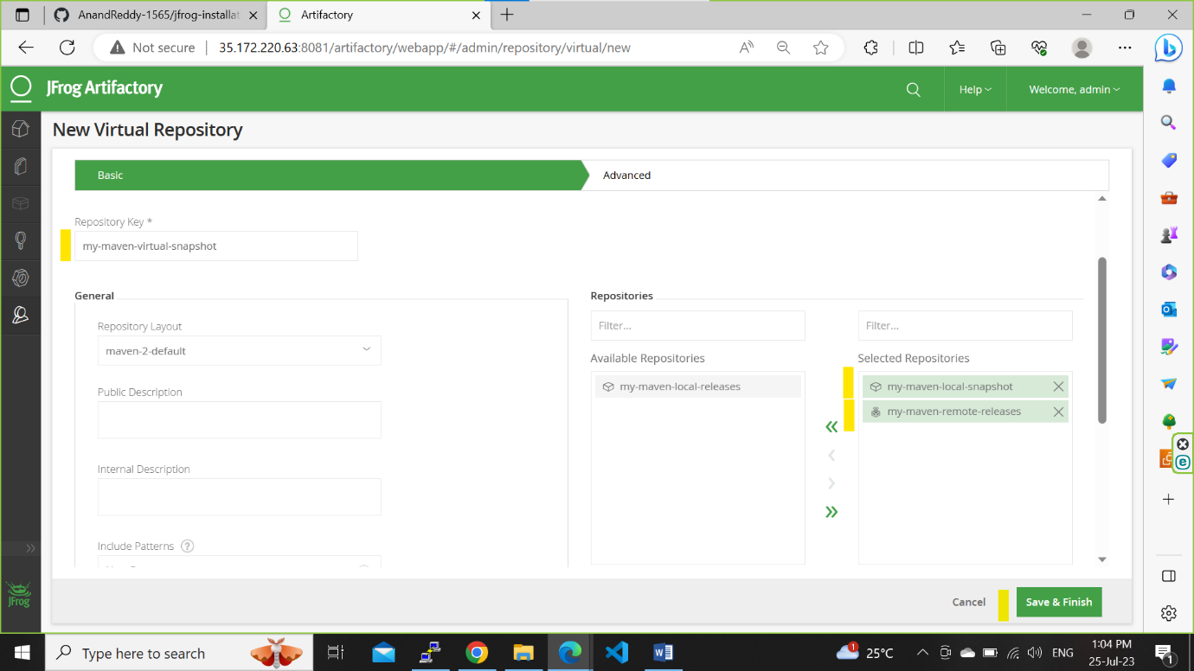

For Virtual-Snapshot Repository and select the both Local-Releases and Remote-Releases

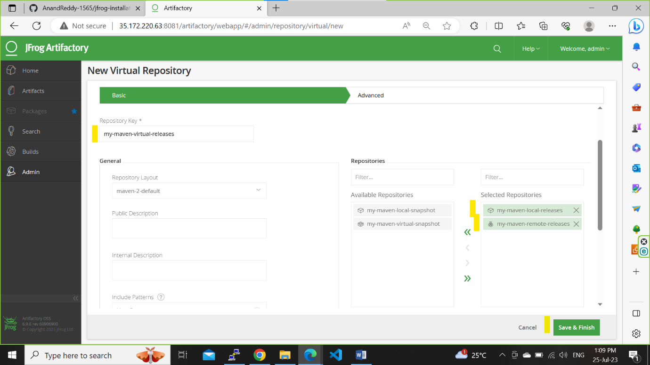

Step 6: Search maven repository in google for resolving artifacts through artifactory

<https://jfrog.com/help/r/TFrtp_Jcpcw1vmlHZ63Gmw/IUrq~hXyu1pHwwivO~_7jg?section=UUID-4b41a634-8d5c-550b-c336-929c015fbc62_id_MavenRepository-ResolvingArtifactsThroughArtifactory>

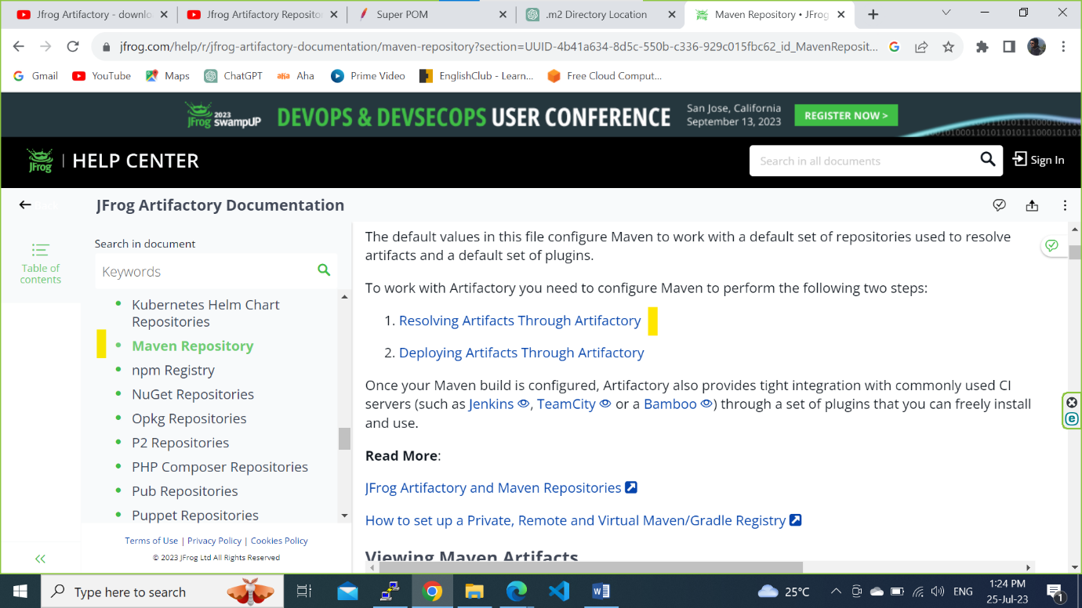

Navigate to setting.xml and copy the POM file.

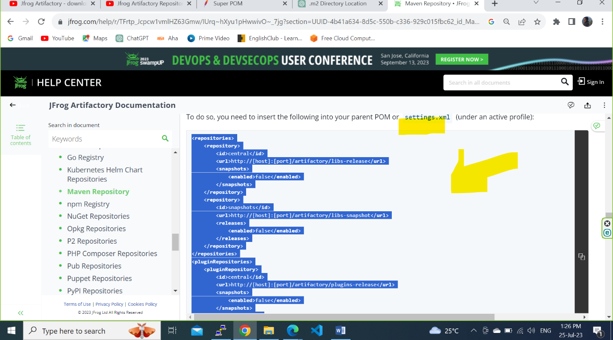

Step 7: select the Virtual-Release and copy the Repository path and paste into the POM file. Similarly click on Virtual-Snapshot and copy the repository path.

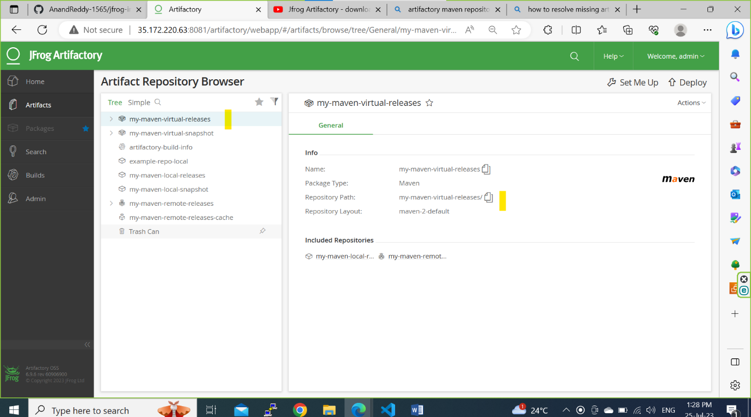

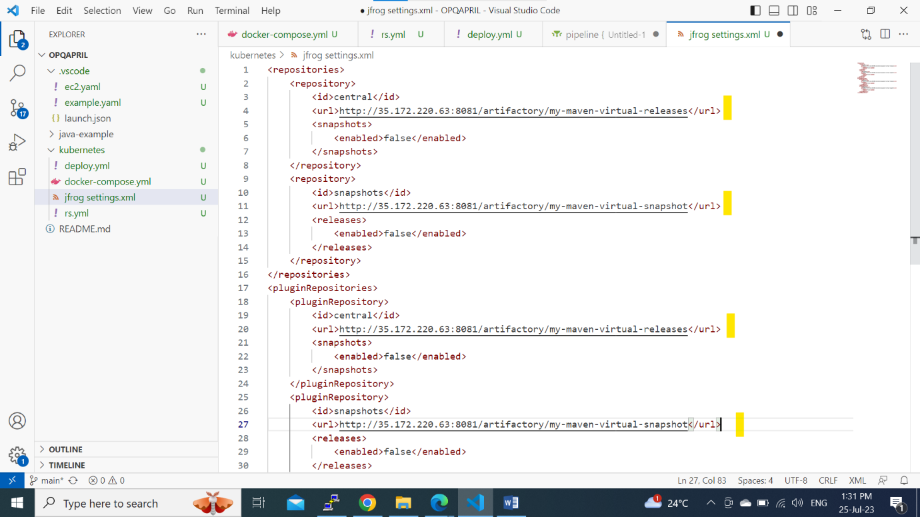

Step 8: Install the maven into the linux server and open the settings.xml file in vi editor

Path for systems.xml: /usr/share/maven/conf/settings.xml

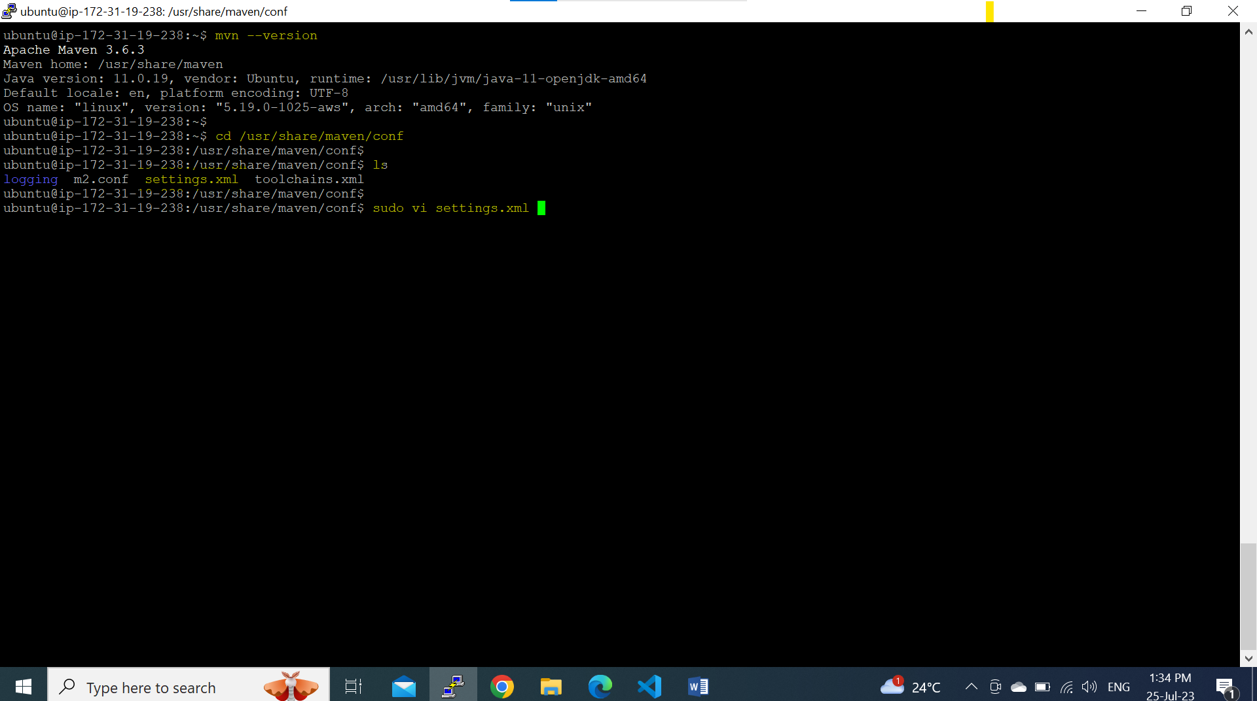

Copy the POM file into the settings.xml inside the </profiles>

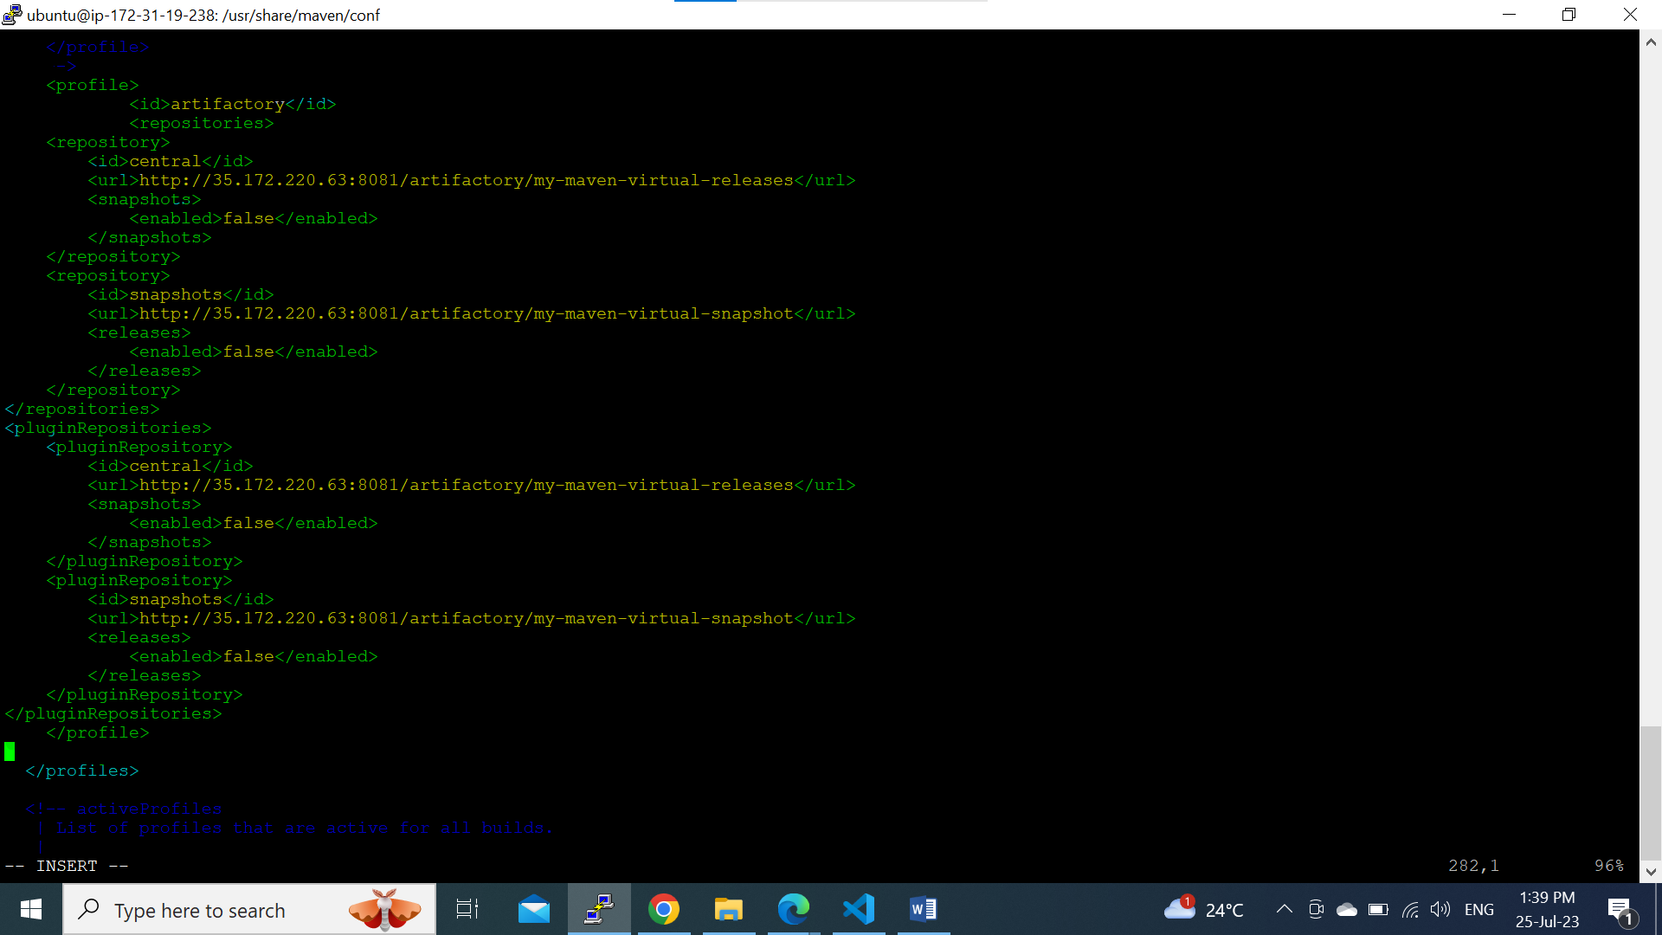

Write artifactory inside the <activeProfiles>

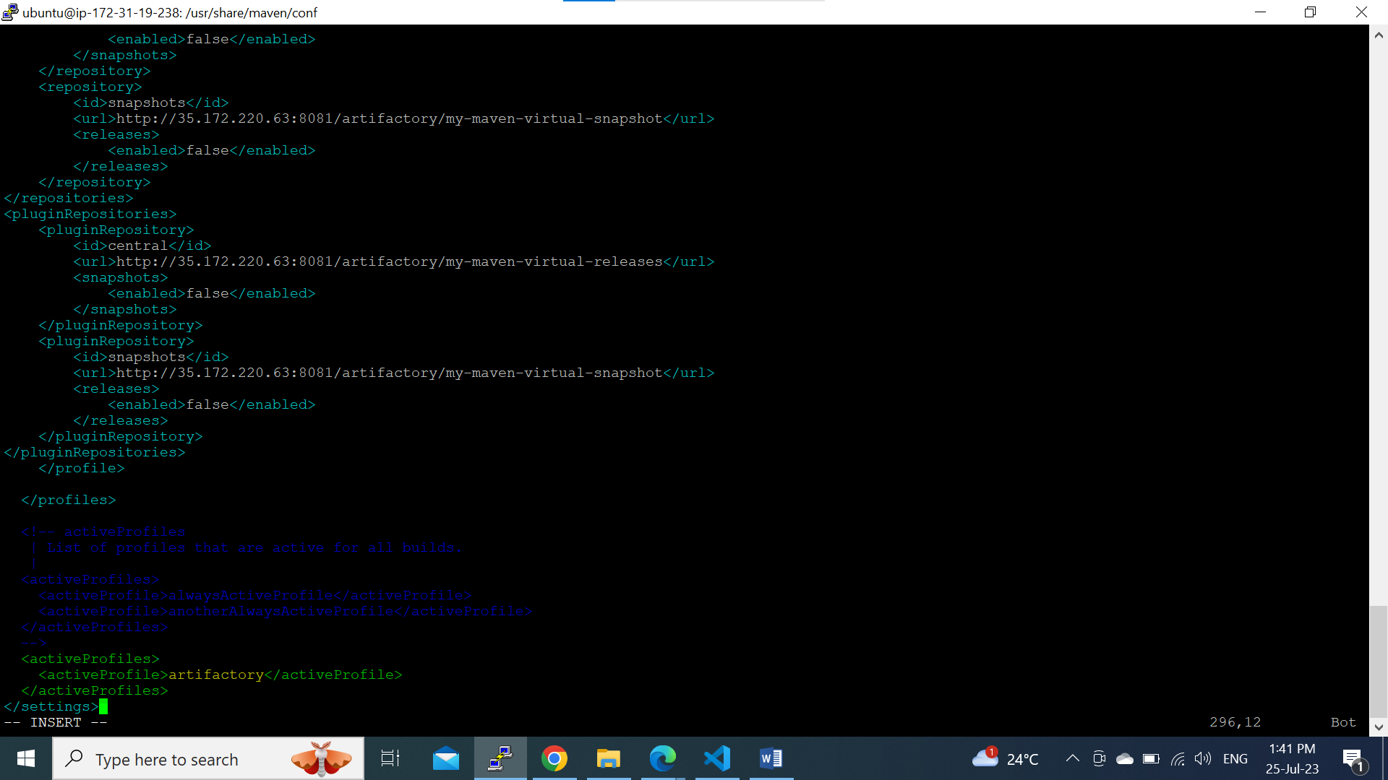

Step 9: Now clone the java-example from github to build a artifact to download the dependencie from the Jfrom Repository.

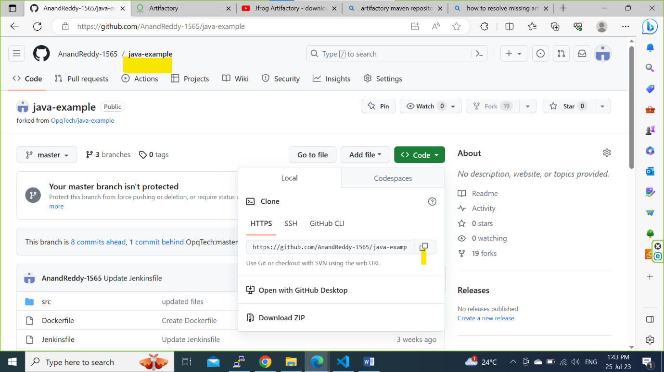

After mvn clean install the dependencies are downloaded from the Jfrog Virtual-Releases repository.

